Named Items Sourcing Guide

Video guide can be found here:
https://www.youtube.com/watch?v=nGz93Pm4XlQ

Primary sources consulted :
The reddit spreadsheet - High End Named Weapons & High End Named Gear tab :
https://docs.google.com/spreadsheets/d/e/2PACX-1vTJEX5DerCvOj3a_m36TRy1gPBAUvrduOIdmXI9j1Y0MpQk1wIXaZ9KOcPa7HzXzp_N5qGmjDj6yEfL/pubhtml#

Last Updated : Y2025 - M12 - D28

Lexicon
LZ : Light Zone, Items listed under LZ drop any place that isn't a dark zone.
DZ : the 3 Dark Zones, Items listed under DZ drop in the dark zones, but also can be gotten from other sources listed below through caches and other means.
LZ + DZ : can drop in either area, available from rewards from either area.
Special : Special sourcing, Explanation below each picture lists them all out.

DZ/PVP Items
DZ/PVP named items can come from these sources:
-DZ item drops, both normal and targeted.
-DZ vendors for DZ credits.
-DZ caches and Conflict caches.
-Named item caches, buyable from countdown store, global events store. and received from season and event reward tracks.
-Legacy caches for DZ/PVP items released in seasons.
-Countdown store 3rd item can be a DZ item at times.
-Incursion key chest will give a named item that can be a DZ/PVP item.
-Reconstructed caches contain 1 named item in the same way as named item caches, and can provide the blueprints for most named items. Reward from Descent and craftable from Retaliation resources.

Special Event items
Certain items are marked as special event items, as listed below.
Special Events are usually centered around holidays, in 2024 this was Summer event in august, and Mooncake event in mid september, and a Christmas event in december.
In 2025 there have been many more events, including Valentines event in februari, Easter event in april, summer event in june/july, and halloween towards the end of october.
Some items like the Lexington, Caretaker and Turmoil were handed out during specific periods, currently they will be available during stretch goals at the end of a season.

Named Weapons
https://docs.google.com/drawings/d/1hisUZoJhg5aDzNux_Ol4ktsgnqkoRxD1E_RTEjdMs9E
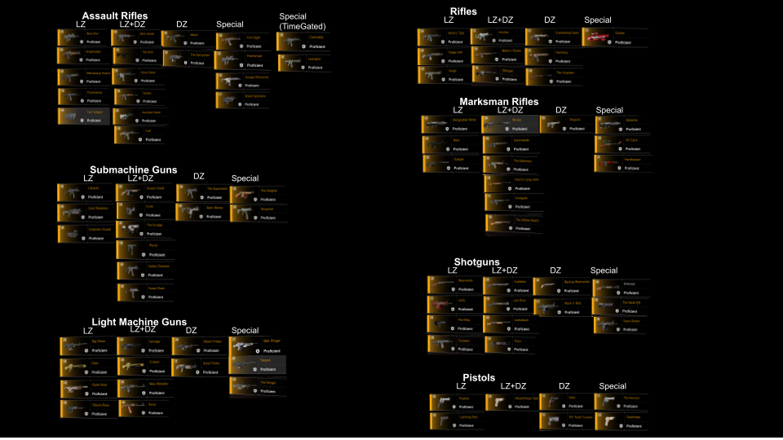
Specials:
First Sight : Drops from holiday hoarder, only available during special events around certain holidays.
Huntsman : Brooklyn hunters reward, comes from chest opened with Ash keys, available at cassie afterwards, blueprint will become available as well after getting all hunter keys.
Savage Wolverine : Craftable, blueprint from stage 4 Firewall research.
Shield Splinterer : Base game hunters reward, comes from chest with Ivory keys, available at cassie afterwards, blueprint will become available as well after getting all hunter keys.
Lexington : First given out Dec 2024 as a Veteran reward, currently will be available from Stretch Goals events towards the end of each season.
Caretaker : First given out with Gamepass Shepherding project Y7S1, currently will be available from Stretch Goals events towards the end of each season.
The Sleigher : Drops from holiday hoarder, only available during special events around certain holidays.
Slingshot : Drops from holiday hoarder, only available during special events around certain holidays.
Bell Ringer : First available from the Winter 2025 even caches, likely only available during special events around certain holidays.
Sleipnir : Craftable, blueprint from stage 4 Gunner research.
The Stinger : Craftable, Blueprint reward from previous friend referral programs, seemingly unavailable now as it is no longer part of the referral rewards.
Enforcer : Preorder of WONY, unavailable now for those that didn’t preorder.
The Send-off : Craftable, blueprint from stage 4 Technician research.
Stack Broker : First given out Black Friday 2025 as a Veteran reward.
Cooler : Drops from holiday hoarder, only available during special events around certain holidays.
Adrestia : Starting item for nemesis quest from tidal basin, drops only there.
Oh Carol : Drops from holiday hoarder, only available during special events around certain holidays.
Handbasket : Drops from holiday hoarder, only available during special events around certain holidays.
The Harvest : Drops from holiday hoarder, only available during special events around certain holidays.
Quickstep : First available from Halloween 25 Event Mini-Warhounds and Caches (still available when completing bounties saved from that event). only available during special events around certain holidays.

Named Gear
https://docs.google.com/drawings/d/1qaUjbH5Cg-1znBfSuL924KCRCYgtIymFm-S7ysI5LUM
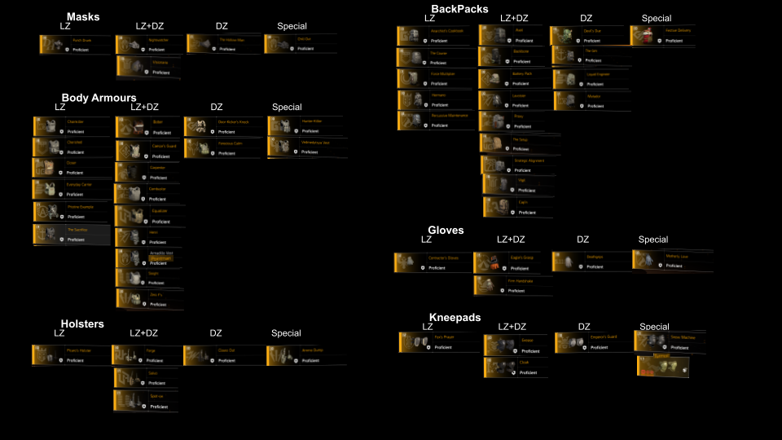
Specials:
Chill Out : Drops from holiday hoarder, only available during special events around certain holidays.
Hunter Killer : WONY hunters reward, comes from chest with Off-White keys, available at cassie afterwards, blueprint will become available as well after getting all hunter keys.
Vedmedytsya Vest : Craftable, blueprint from stage 2 Gunner research.
Ammo Dump : Craftable, blueprint from stage 2 Firewall research.
Festive Delivery : Drops from holiday hoarder, only available during special events around certain holidays.
Motherly love : Craftable, blueprint from stage 2 Technician research.
Snow Machine : Drops from holiday hoarder, only available during special events around certain holidays.
Turmoil : First given out with April Fools 2025, currently will be available from Stretch Goals events towards the end of each season.

Mission Specific Named Items
For some named items there are now also tied to an increased drop rate while running certain missions, this is based on the list below, and is not a guaranteed drop, but just increased chances at that named item while doing that mission.

- Camp White Oak: Pyromaniac, Mechanical Animal, Kingbreaker.
- The Pentagon: New Reliable.
- DARPA Research Labs: Lefty.
- Roosevelt Island: White Death.
- Manning National Zoo: White Death.
- Coney Island Amusement Park: Burn Out, Born Great.
- Tidal Basin: Dare, Big Show.
- Coney Island Ballpark: Tabula Rasa, Carnage.
- Bank Headquarters: Cabaret, Grown Great, Swap Chain.
- Capitol Hill: Safety Distance, Emeline's Guard, Cold Relations. (currently The Apartment also)
- Viewpoint Museum: Cuelebre, Tsunami
- District Union Arena: Baker's Dozen, Stage Left.
- Space Administration HQ: Ekim's Long Stick, Designated Hitter, Scalpel.
- Air & Space Museum: Prophet.
- Jefferson Plaza: Invisible Hand, Glory Daze, Test Subject.
- Jefferson Trade Center: Quiet Roar.
- Federal Emergency Bunker: Boomstick, Backup Boomstick, The Mop.
- American History Museum: Surge, Artist's Tool.
- Potomac Event Center: Relic, Commando.
- Grand Washington Hotel: Lightning Rod.

Links to my other guides, the Build Collection, DMG/DPS Calculators and many other things:

https://docs.google.com/document/d/15mg-_sjowh5_8bUp2VIBqnDxCDqz-xJOISl0DlG3RDU

